**Project Design Phase**

**Solution Architecture**

|  |  |
| --- | --- |
| Date | 26 -06- 2025 |
| Team ID | LTVIP2025TMID49207 |
| Project Name | Measuring the Pulse of Prosperity: An Index of Economic Freedom Analysis |
| Maximum Marks | 4 Marks |

**Solution Architecture:**

Solution architecture is a structured discipline that aligns business objectives with technology capabilities to address complex problems effectively. In this project, the solution architecture provides a blueprint for building a transparent, reliable, and scalable system to measure and analyze economic freedom as a driver of prosperity.

The architecture covers the complete flow — from data collection to insight generation — to ensure the Economic Freedom Index is accurate, reproducible, and meaningful for policymakers and researchers.

**Architecture Components**

# Data Sources

* Primary economic indicators (GDP, regulatory burden, tax freedom, property rights, trade freedom, etc.)
* Publicly available databases (World Bank, IMF, OECD, Heritage Foundation)
* National statistical agencies

# Data Ingestion

* Automated ETL (Extract, Transform, Load) pipelines built using tools like Apache Airflow, Talend, or custom Python scripts
* Scheduled data refresh to ensure consistency and up-to-date information

# Data Storage

* Cloud-based data warehouse solutions (AWS Redshift, Google BigQuery, or Azure Synapse)
* Structured schema supporting efficient querying, secure storage, and scalability

# Data Processing & Transformation

* Data cleaning: remove inconsistencies, handle missing values, and standardize indicators
* Data enrichment: apply weights, normalization, and scoring to build the Economic Freedom Index
* Feature engineering: design derived metrics for deeper insights

# Analytics Layer

* Statistical modeling (regressions, clustering)
* Machine learning algorithms (trend detection, anomaly detection)
* Time series analysis for forecasting prosperity scores

# Visualization & Reporting

* Interactive dashboards using Power BI, Tableau, or Plotly Dash
* Custom reporting APIs to deliver machine-readable data for policy tools
* Charts, heat maps, rankings, and time series views

# Stakeholder Access & Security

* Web portal for policymakers and analysts
* Role-based access control to protect sensitive data
* Audit trails for data integrity and compliance

# Development Phases

Phase 1: Requirements gathering and stakeholder interviews

Phase 2: Design of data pipelines and schema

Phase 3: Data acquisition and transformation

Phase 4: Index modeling and scoring logic

Phase 5: Visualization and dashboard building

Phase 6: User testing, final deployment, and knowledge transfer

# Key Benefits

Transparent and explainable index methodology

Scalable and automated updates for long-term sustainability

Actionable insights through advanced visualizations

Better decision-making for economic reform initiatives

**Solution Data Flow Diagram :**

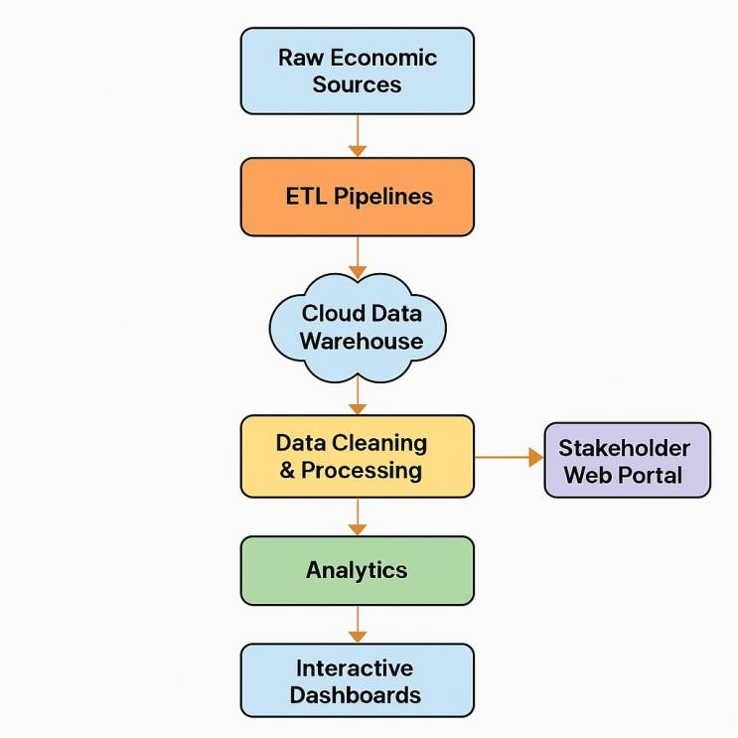

**Figure 1:** Solution Data Flow Diagram for Measuring the Pulse of Prosperity Project

**Example - Solution Architecture Diagram:**

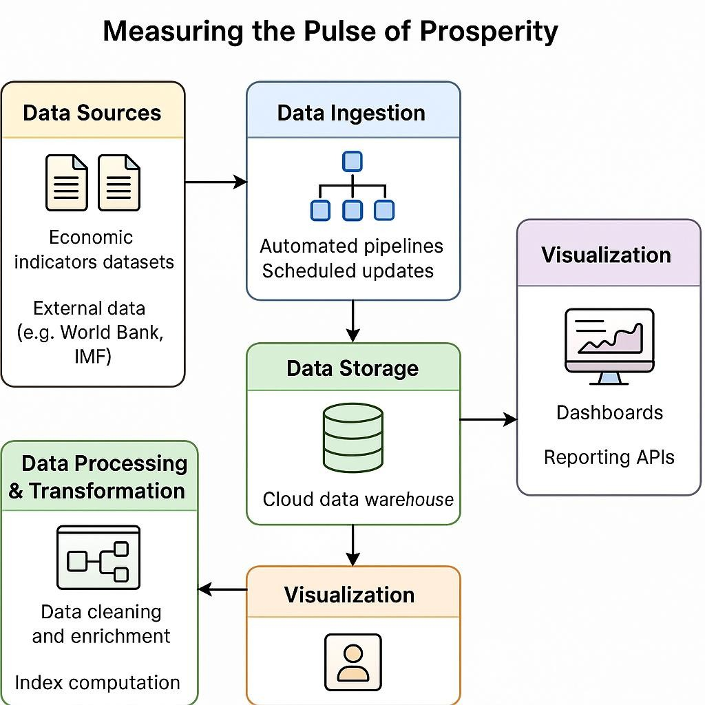

**Figure 2:** Solution Architecture Diagram for Measuring the Pulse of Prosperity Project **Reference:** [**https://aws.amazon.com/blogs/industries/voice-applications-in-clinical-researchpowered-by-ai-on-aws-part-1-architecture-and-design-considerations/**](https://aws.amazon.com/blogs/industries/voice-applications-in-clinical-research-powered-by-ai-on-aws-part-1-architecture-and-design-considerations/)